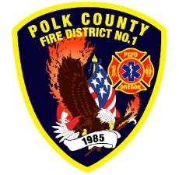Fire Prevention Report

**For Board Meeting, September 12, 2024**

**By Division Chief Fire Marshal Troy Crafton**

**August’s Events** (Plan Review, Inspections, Training, Incident Response)

* Nation Night Out
* Pub Ed at Family Building Blocks
* WOU Student Success Sprinkler and FDC Inspection
* 140 Main Street W Final sprinkler inspection
* G & R License Inspection
* Pick-A-Part License Inspection
* 900 N Main Inspection
* Walgreens Final Inspection
* 238 Jackson St Final Inspection
* Strategic Planning Meeting
* ADU Inspection and Addressing
* 12 Building Inspection
* 12 Plan Reviews
* 2 Smoke Alarm Installs
* Active 911 Maintenance
* Flow MSP set up and Pre-Plans
* Risk Reduction Grant for District Addressing / Preplanning
* Plan Review IGA Planning With Monmouth And Independence Building Departments
* 7 Hours Fire Marshal Service IGA Dallas Fire Department
* 7 Incidents With 4.50 Hours Of Response

**Upcoming Events** (Plan Review, Inspections, Training)

* Officer Meeting September 4th
* Pre-App Meeting Monmouth September 5th
* Monmouth City Project Meeting September 12th
* IAAI Conference September 16th – 19th
* PUB ED at Indy Library September 24th
* Dallas DRT Meeting Every Thursday

**Activities** (Meetings)

* Officer Meeting August 7th
* Monmouth City Project Meeting August 8th
* Community Fiesta Independence Meeting August 15th
* MPFIT Meeting August 20th
* Dallas DRT Meeting Every Thursday