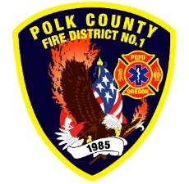Fire Prevention Report

**For Board Meeting, October 10, 2024**

**By Division Chief Fire Marshal Troy Crafton**

**September’s Events** (Plan Review, Inspections, Training, Incident Response)

* IAAI Conference September 16th – 19th
* PUB ED at Indy Library September 24th
* Fire Alarm Inspection 495 I Street
* WOU Hydrant testing
* Inspection at 730 E Clay Monmouth
* WOU Student Success FDC Inspection
* Strategic Planning Meeting
* ADU Inspection and Addressing
* 14 Plan Reviews
* 2 Smoke Alarm Installs
* Active 911 Maintenance
* Flow MSP set up and Pre-Plans
* Risk Reduction Grant for District Addressing / Preplanning
* 7 Hours Fire Marshal Service IGA Dallas Fire Department
* 6 Incidents With 6.25 Hours Of Response

**Upcoming Events** (Plan Review, Inspections, Training)

* Safety Committee Meeting First Tuesday of the Month
* Monthly Officer Meeting
* Monthly Monmouth City Project Meeting
* Monmouth Building Meeting Every Thursday
* Dallas DRT Meeting Every Thursday
* MPFIT Meeting
* Pre-Application Conference 24-05
* Pre-App: Neighborhood Commercial (PRE 24-06)
* PUB ED at Ash Creek
* PUB ED at IES
* PUB ED Monmouth Library
* PUB ED at MES
* Monmouth Park Halloween Event
* Community Trick Or Treat
* Active Shooter Training At Grand Ronde
* Steps To Safety Training

**Activities** (Meetings)

* Safety Committee Meeting September 3rd
* Officer Meeting September 4th
* Pre-App Meeting Monmouth September 5th
* Monmouth City Project Meeting September 12th
* Dallas DRT Meeting Every Thursday